**—** **Software Development Project —**

**(CS 691)**

**Name: Mohammed Arbaz Ahmed**

**LIU ID: 100789938**

**Assignment** - **Database design**

**Project Name - SkillBridge**

**Instructions:**

### **Step 1: Identify Entities and Their Attributes**

To create an optimized database, we first need to determine the primary entities (tables) representing different elements of the system. In this scenario, we are designing a Skill-Bridge platform, which facilitates connections between professionals and companies for short-term projects, internships, or mentorship opportunities.

#### **Entities and Their Attributes**

* Users (stores details of all users, including professionals and recruiters)
  + user_id (PK, Unique identifier for each user)
  + first_name
  + last_name
  + email (Unique)
  + password
  + user_type (ENUM: ‘Professional’, ‘Recruiter’)
  + created_at (Timestamp)
* Profiles (holds additional details about professionals)
  + profile_id (PK)
  + user_id (FK)
  + bio
  + skills (Stored as comma-separated values or JSON)
  + experience_level (ENUM: ‘Beginner’, ‘Intermediate’, ‘Expert’)
  + linkedin_url
* Companies (stores recruiter company details)
  + company_id (PK)
  + company_name
  + industry
  + location
  + website
* Projects (short-term assignments posted by recruiters)
  + project_id (PK)
  + company_id (FK)
  + title
  + description
  + required_skills (Stored as JSON or comma-separated values)
  + budget
  + status (ENUM: ‘Open’, ‘Closed’, ‘In Progress’)
  + created_at (Timestamp)
* Applications (records applications submitted by professionals)
  + application_id (PK)
  + project_id (FK)
  + user_id (FK)
  + cover_letter
  + status (ENUM: ‘Pending’, ‘Accepted’, ‘Rejected’)
  + applied_at (Timestamp)
* Reviews (stores feedback and ratings for professionals)
  + review_id (PK)
  + reviewer_id (FK, references user_id of recruiter)
  + professional_id (FK, references user_id of professional)
  + rating (Scale of 1-5)
  + comments
  + reviewed_at (Timestamp)

### **Step 2: Define Relationships Between Entities**

* Users and Profiles → One-to-One (Each user has a single profile)
* Users and Companies → One-to-Many (A recruiter is linked to a company, but a company can have multiple recruiters)
* Companies and Projects → One-to-Many (A company can list multiple projects)
* Users and Projects (via Applications) → Many-to-Many (Professionals can apply for multiple projects, and a project can receive applications from multiple professionals)
* Users and Reviews → One-to-Many (A professional can receive multiple reviews from different recruiters)

### **Step 3: Implement the ER Diagram**

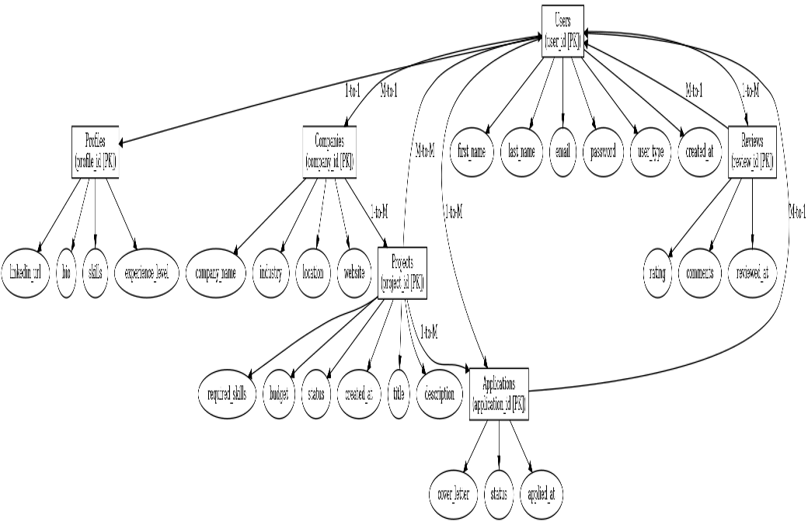

### **Database Table Definitions**

Below are the SQL table definitions adhering to **1NF, 2NF, and 3NF** normalization principles.

#### **1. Users Table**

CREATE DATABASE SkillBridge;

USE SkillBridge;

CREATE TABLE Users (

user_id INT PRIMARY KEY AUTO_INCREMENT,

first_name VARCHAR(50) NOT NULL,

last_name VARCHAR(50) NOT NULL,

email VARCHAR(100) UNIQUE NOT NULL,

password VARCHAR(255) NOT NULL,

user_type ENUM('Professional', 'Recruiter') NOT NULL,

created_at TIMESTAMP DEFAULT CURRENT_TIMESTAMP

);

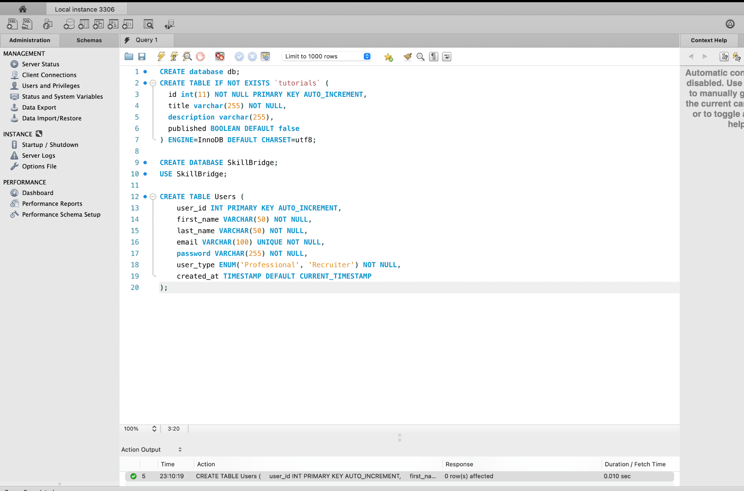

**2. Profit Table**

CREATE TABLE Profiles (

profile_id INT PRIMARY KEY AUTO_INCREMENT,

user_id INT,

bio TEXT,

skills TEXT,

experience_level ENUM('Beginner', 'Intermediate', 'Expert') NOT NULL,

linkedin_url VARCHAR(255),

FOREIGN KEY (user_id) REFERENCES Users(user_id) ON DELETE CASCADE

);

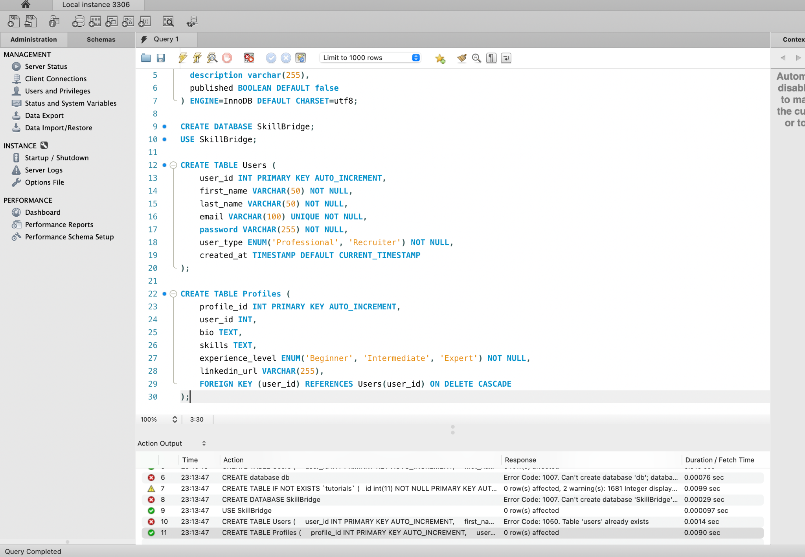

**3. Companies Table**

CREATE TABLE Companies (

company_id INT PRIMARY KEY AUTO_INCREMENT,

company_name VARCHAR(100) NOT NULL,

industry VARCHAR(50),

location VARCHAR(100),

website VARCHAR(255)

);

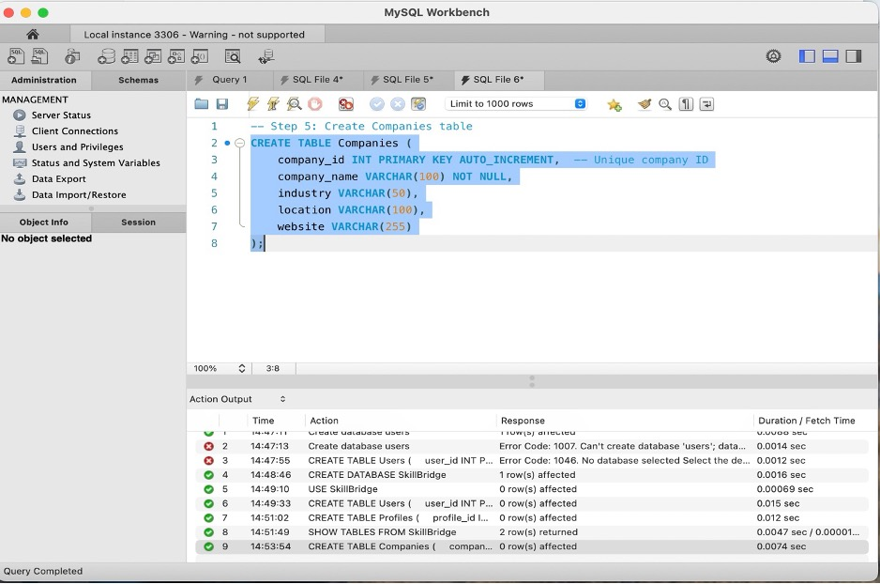

**4. Project Table**

CREATE TABLE Projects (

project_id INT PRIMARY KEY AUTO_INCREMENT,

company_id INT,

title VARCHAR(100) NOT NULL,

description TEXT,

required_skills TEXT,

budget DECIMAL(10,2),

status ENUM('Open', 'Closed', 'In Progress') NOT NULL,

created_at TIMESTAMP DEFAULT CURRENT_TIMESTAMP,

FOREIGN KEY (company_id) REFERENCES Companies(company_id) ON DELETE CASCADE

);

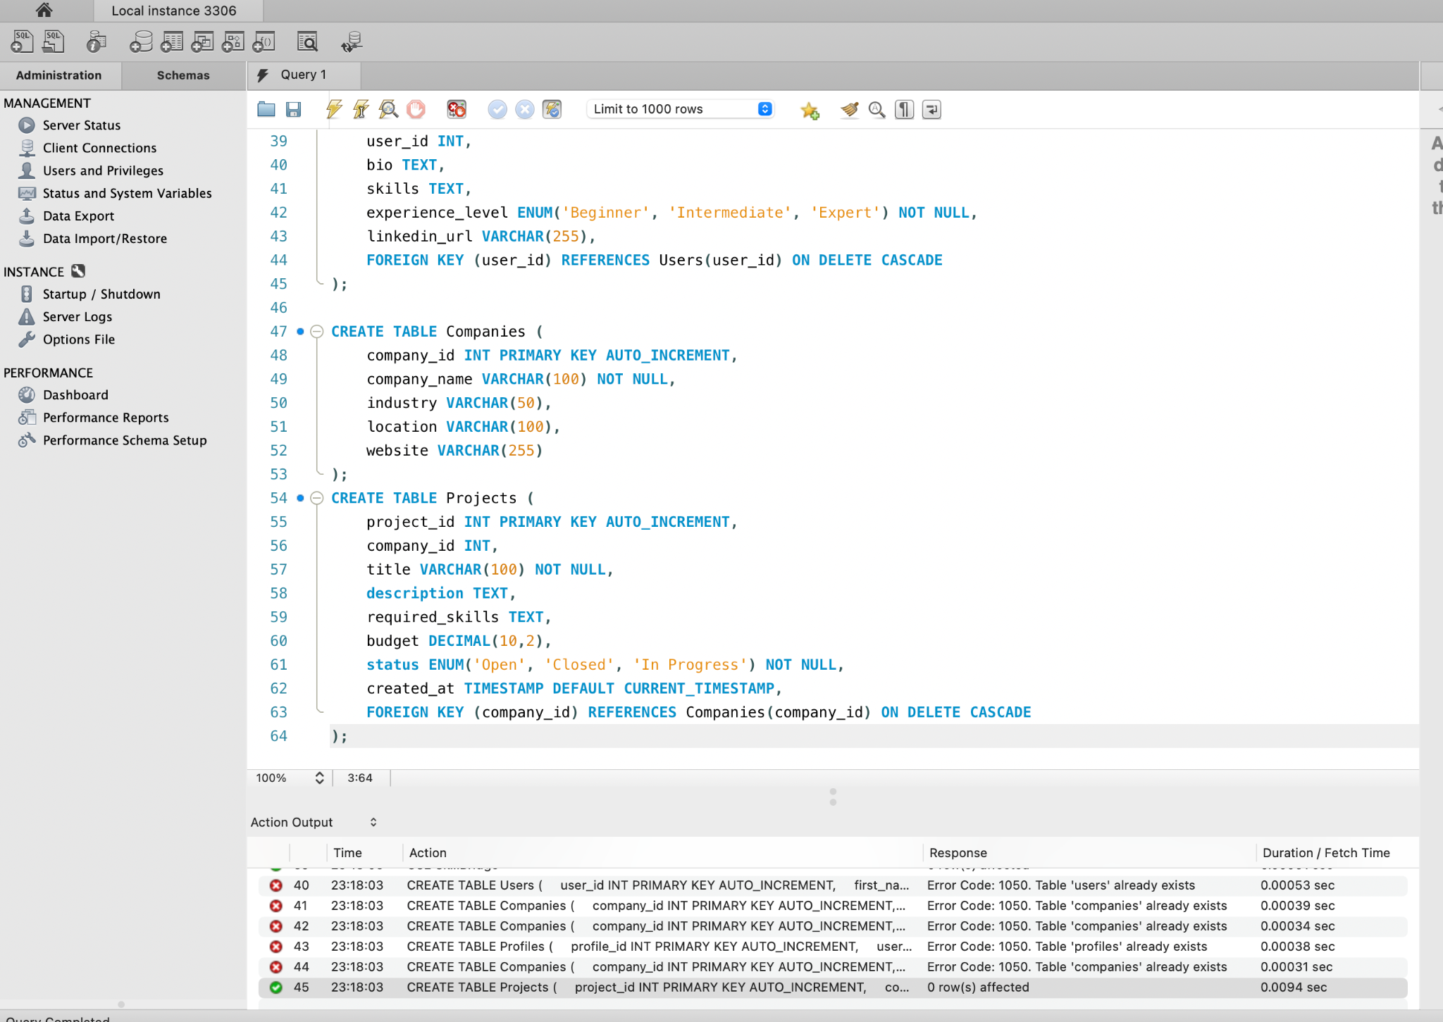

**5. Applications Table**

CREATE TABLE Applications (

application_id INT PRIMARY KEY AUTO_INCREMENT,

project_id INT,

user_id INT,

cover_letter TEXT,

status ENUM('Pending', 'Accepted', 'Rejected') NOT NULL,

applied_at TIMESTAMP DEFAULT CURRENT_TIMESTAMP,

FOREIGN KEY (project_id) REFERENCES Projects(project_id) ON DELETE CASCADE,

FOREIGN KEY (user_id) REFERENCES Users(user_id) ON DELETE CASCADE

);

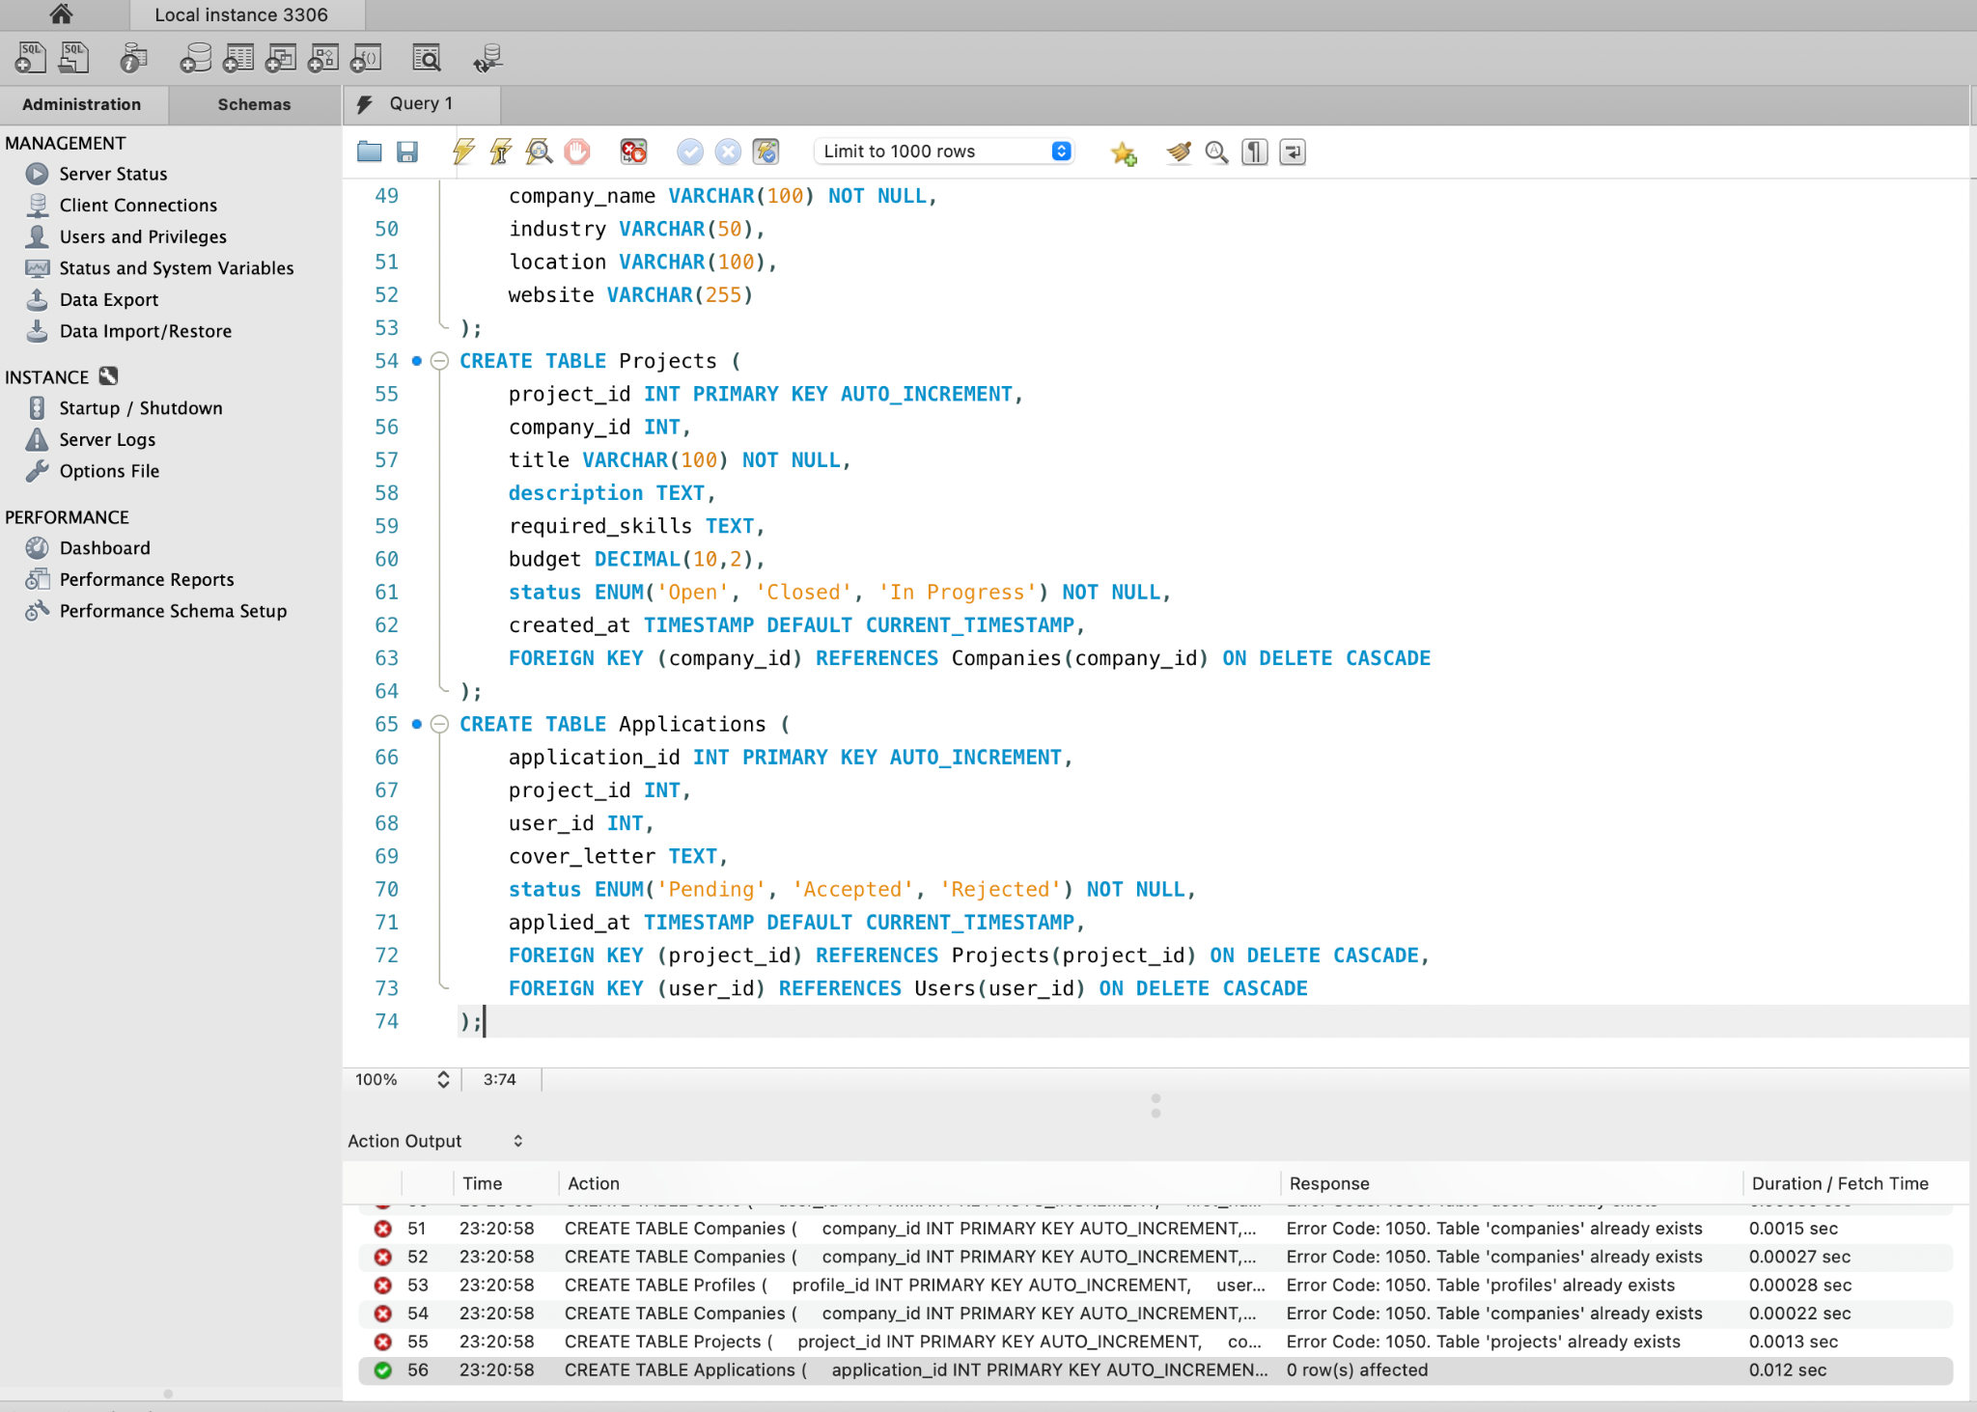

**6. Reviews Table**

CREATE TABLE Reviews (

review_id INT PRIMARY KEY AUTO_INCREMENT,

reviewer_id INT,

professional_id INT,

rating INT CHECK(rating BETWEEN 1 AND 5),

comments TEXT,

reviewed_at TIMESTAMP DEFAULT CURRENT_TIMESTAMP,

FOREIGN KEY (reviewer_id) REFERENCES Users(user_id) ON DELETE CASCADE,

FOREIGN KEY (professional_id) REFERENCES Users(user_id) ON DELETE CASCADE

);

